fORged by

Amazon

Web Services

and cORe

Mahindra Venkat Lukka

1. **Insights from given data:**
   1. **Seasonality and Holidays:** We can see from the below graph that the data is following a seasonality across months in every year.

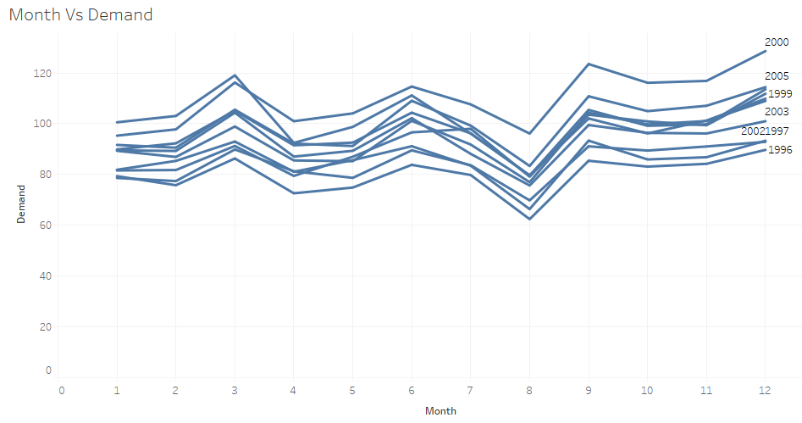

* 1. **Trend:** From the graph below, we can observe an increase in demand over months trend.

Based on the above insights, we should consider seasonality and holidays, trends as our independent variables for our demand prediction regression.

1. **Mathematical Description:**

Related to these regression variables, I found a paper, “Forecasting at Scale” by Sean J. Taylor and Benjamin Letham. It explains the same and gives the regression equation as,

Y(t) = g(t) + s(t) + h(t) + Ꞓt

Where, g(t) is trend function, s(t) is seasonality function (Monthly in our case), h(t) is the effect of holidays function (We can consider this function for daily data) and Ꞓt is the error term.

***2.1 Trend Analysis:***

As the problem given is related to hardware sales and this item has very less saturation possibilities. So, from the paper which I referred before, a piece-wise constant rate

of growth provides a parsimonious and often useful model. So, our trend model is,

g(t) = (k + a(t)Tδ)t + (m + a(t)Tγ)

Where, k is the growth rate, δ has the rate adjustments, m is the offset parameter, and γj is set to -sjγj to make the function continuous.

***2.2 Seasonality Analysis:***

To fit and forecast the seasonality effect we must specify seasonality models that are periodic functions of t. We can approximate arbitrary smooth seasonal effects with,

s(t) = $\sum_{n=1}^{N}{\left(a_{n}\cos{\frac{2nπt}{P}}+b_{n}\sin{\frac{2nπt}{P}}\right)}$

Where, P be the regular period we expect the time series to have (e.g. P = 30 days in our case for monthly data)

1. **Methodology:**
2. Selected 9 years from 1996 to 2004 as training data and year 2005 as testing data.
3. Various forecasting methods like simple average method, linear regression method, exponential regression method and prophet method were used.
4. Measure or metric for comparison is root mean square error (RMSE) and the cost occurred due to holding and backorders in the test year 2005.
5. By comparing all these methods, we get one optimal method. From this optimal method, we get the forecasted demand for next 2 years.
6. As there will be an uncertainty exists in demand forecast, we have to forecast a point estimate with upper and lower limits.
7. From this forecasts and error limit values, we should find the optimal on-hand quantity for every month including ordered quantity for that month and previous month’s ending inventory. The main constraint for calculation is, total cost by using upper limit demand forecast equal to total cost by using lower limit demand forecast. This can be found in GitHub with file name Weighted Model.xlsx
8. From this calculation, in real time we can back calculate the ordering quantity based on inventory available.
9. NASDAQ data can be considered in giving weightage to our forecast. After analyzing the NASDAQ data and demand given, I felt that weightage is not giving significant advantage in our forecast.
   1. ***Forecast Test Results:***

*3.1.1 Simple average method:*

RMSE for year 2005 is 11.75

Cost including Holding cost and Backorder cost is 267.46

* + 1. *Linear regression method:*

RMSE for year 2005 is 9.997

Cost including Holding cost and Backorder cost is 513.22

* + 1. *Exponential regression method:*

RMSE for year 2005 is 9.922

Cost including Holding cost and Backorder cost is 503.51

* + 1. *Prophet method:*

RMSE for year 2005 is 3.054

Cost including Holding cost and Backorder cost is 81.73

***3.2 Insights from Test Results:***

By comparing all methods mentioned above, forecasting demand by prophet method gives lowest RMSE value and lowest cost. So, Prophet method gives the optimum solution.

1. **How to run the forecast model:**

I used open source Prophet library from Facebook (fbprophet). We need to install pystan and fbprophet to run my python code. Please find my .py file and .ipynp files in GitHub. (We can install these by using pip install fbprophet, pip install pystan)

1. **Results:**

By running my python code, demand for years 2006 and 2007 were forecasted on monthly basis with upper and lower limits. The forecasted demand values are,

|  |  |  |  |
| --- | --- | --- | --- |
| **Month-Year** | **Point Estimate** | **Lower Limit** | **Upper Limit** |
| Jan-06 | 100.26 | 93.99 | 106.81 |
| Feb-06 | 100.00 | 93.27 | 106.40 |
| Mar-06 | 106.35 | 98.35 | 114.43 |
| Apr-06 | 92.11 | 84.29 | 100.39 |
| May-06 | 98.34 | 90.11 | 106.06 |
| Jun-06 | 111.27 | 102.77 | 119.31 |
| Jul-06 | 104.74 | 96.21 | 112.94 |
| Aug-06 | 82.98 | 74.67 | 91.35 |
| Sep-06 | 111.14 | 103.34 | 118.96 |
| Oct-06 | 108.85 | 100.07 | 117.06 |
| Nov-06 | 105.74 | 96.80 | 114.04 |
| Dec-06 | 113.26 | 104.47 | 121.85 |
| Jan-07 | 104.63 | 96.23 | 112.79 |
| Feb-07 | 104.00 | 94.56 | 112.65 |
| Mar-07 | 108.50 | 98.27 | 118.57 |
| Apr-07 | 94.35 | 83.62 | 104.59 |
| May-07 | 101.57 | 91.14 | 111.74 |
| Jun-07 | 114.86 | 103.38 | 125.39 |
| Jul-07 | 108.59 | 97.39 | 118.93 |
| Aug-07 | 85.07 | 74.35 | 95.22 |
| Sep-07 | 114.26 | 102.46 | 125.34 |
| Oct-07 | 112.51 | 99.42 | 124.87 |
| Nov-07 | 108.31 | 95.96 | 120.19 |
| Dec-07 | 115.79 | 101.49 | 128.93 |

Based on these forecasted estimates and variances and considering the inventory available (73 Pieces) in Dec 2005, we can plan our inventory system (Ordering quantities in respective months) to optimize back order and holding costs considering 1-month lead time.

*Forecast graph by running forecast model,*

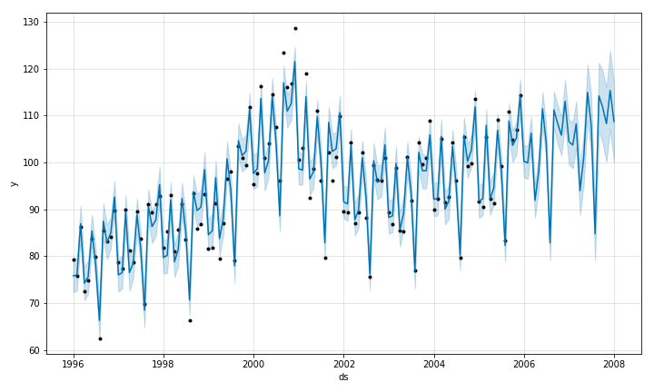

*Trend and Seasonality graphs by model,*

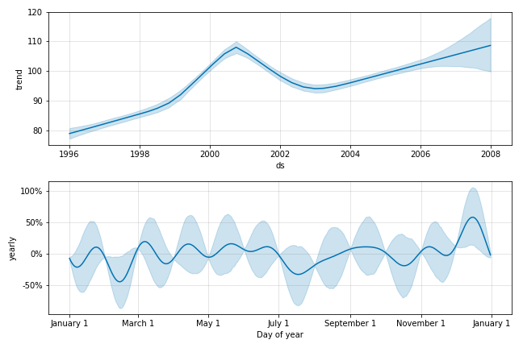

1. **Inventory Planning:**

From the forecasted demand and their upper and lower limits, I found the required optimal on-hand quantity for every month including ordered quantity for that month (Lead Time – 1 Month) and previous month’s ending inventory. This needs to be calculated because of different costs for holding and backorder costs. The main constraint for calculation is, total cost by using upper limit demand forecast equal to total cost by using lower limit demand forecast. This can be found in GitHub with file name Weighted Model.xlsx

From the solver result, our inventory planning system is to maintain the below number of pieces on starting day of each month.

|  |  |  |  |  |  |  |  |  |  |  |  |  |
| --- | --- | --- | --- | --- | --- | --- | --- | --- | --- | --- | --- | --- |
| **Months** | **Jan-06** | **Feb-06** | **Mar-06** | **Apr-06** | **May-06** | **Jun-06** | **Jul-06** | **Aug-06** | **Sep-06** | **Oct-06** | **Nov-06** | **Dec-06** |
| Units | 103.60 | 103.12 | 110.41 | 96.36 | 102.08 | 115.18 | 108.76 | 87.18 | 115.05 | 112.82 | 109.73 | 117.50 |

|  |  |  |  |  |  |  |  |  |  |  |  |  |
| --- | --- | --- | --- | --- | --- | --- | --- | --- | --- | --- | --- | --- |
| **Months** | **Jan-07** | **Feb-07** | **Mar-07** | **Apr-07** | **May-07** | **Jun-07** | **Jul-07** | **Aug-07** | **Sep-07** | **Oct-07** | **Nov-07** | **Dec-07** |
| Units | 108.65 | 108.12 | 113.50 | 99.35 | 106.59 | 119.89 | 113.55 | 90.00 | 119.62 | 118.51 | 114.13 | 122.07 |

From this calculation, in real time for each month, we can back calculate the ordering quantity based on inventory available

**References:**

1. “Forecasting at Scale” by Sean J. Taylor and Benjamin Letham.